Semester One Examination, 2022

MODERN HISTORY

SOURCE BOOKLET

Source Set | Elective | Related question
1 | Australia 1918-1955 | 1
2 | Russia and the Soviet Union 1914 - 1945 | 1
3 | China 1935 – 1989 | 1
4 | Australia 1918-1955 | 11
5 | Russia and the Soviet Union 1914 - 1945 | 11
6 | China 1935 – 1989 | 11

Set 1: Elective 1: Australia 1918-1955
Source 1
(A cartoon that appeared in The Bulletin in November 1954 with the caption ‘Like a shag on a rock’. ‘Like a shag on a rock’ is a phrase that means ‘completely alone’ or ‘isolated’.)

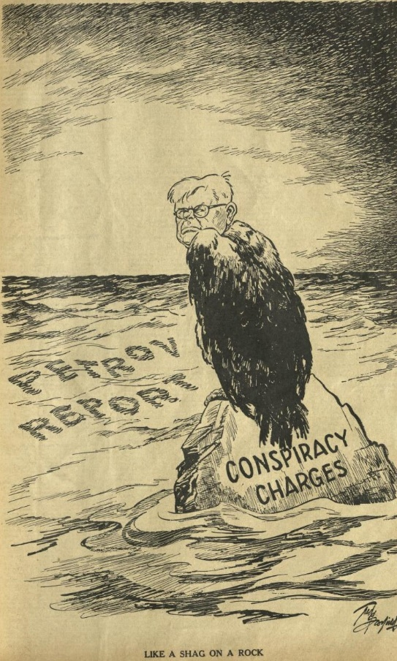

Source 2

(Extract from a speech by Dr. H. V. Evatt in Parliament in October 1955, about the Royal Commission on Espionage.)

The report of the Royal Commission on Espionage requires forthright analysis and plain speaking. What is the upshot of this Petrov affair? Two foreigners, the Petrovs, and one foreign-born Australian spy, Bialoguski, have made a lot of money. The forum in which they appeared cost the taxpayers £140,000, plus unlimited security service expenses. The nation has suffered heavy losses in trade, and the breaking of diplomatic relations with a great power. There has been the attempted smearing of many innocent Australians, grave inroads have been made into Australian freedoms by attacks on political non-conformity. But after eighteen months of inquiry, at this great cost to the nation, no spies have been discovered. Not a single prosecution is recommended.
It is now clear that the Prime Minister (Mr. Menzies) must have known, when appointing the commission, that there would be no legal evidence fit to warrant the prosecution of any person, that there was in fact no security ground for the inquiry itself. Indeed, the inquiry has in many ways been destructive of the national security of Australia. Furthermore, it is now abundantly clear that the Prime Minister knew many months before the 13th April, 1954, when he made his melodramatic and coldly calculated announcement to the House, that Petrov’s defection was being deliberately organised by security agents under his ministerial control. He waited, and sprang the announcement on the House on the very last sitting night of the Parliament prior to the May general elections. He completely deceived the House into rushing through legislation to appoint a commission. In the apparent emergency, there was no opportunity of examining any of the basic facts. His statements should be re-read in the cold light of the facts which have since been established during the last eighteen months since the 13th April, 1954.
See next page
Source 3
(A cartoon that appeared in The Herald Newspaper in March 1955.)

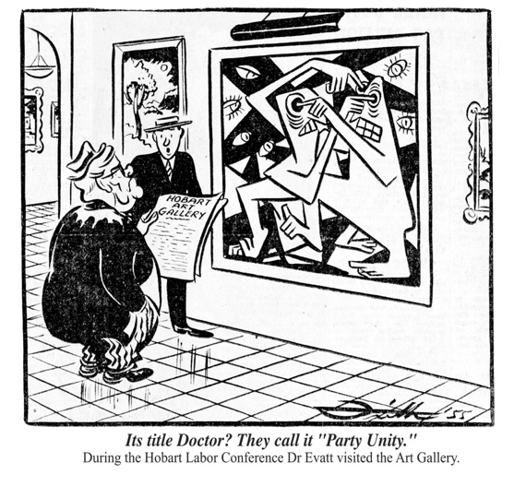
Source 4
(Extract from a website called The Petrov Affair addressing the 1955 split of the Labor Party.)

The greatest domestic outcome of the Petrov Affair was the Labor Party Split, which had immediate and long-lasting consequences for the Labor Party and the Australian political landscape. Evatt’s position on the Petrov Affair inflamed existing divisions within the Labor Party. The anti-Communist Right of the Party bitterly opposed the conspiracy theory that Evatt mounted at the Petrov Royal Commission. They believed his conspiracy theory amounted to a defence of Communism.

After a series of dramatic meetings, involving fist-fights and wild accusations, disagreement became violent dissent within the caucus… Evatt believed the Catholic group, The Movement, was directing a small group within the ALP to subvert the Party. As a result of Evatt’s charge the ALP Federal Executive called for a review of Labor’s Victorian branch…

Following its inquiry into the Victorian branch, the ALP Federal Executive dismissed the Victorian State Executive and appointed a new one. Both the old and the new Executives sent delegations to the ALP conference in Hobart in March 1955 but only the new Executive was admitted. The old Executive was locked out of the Conference. In the political turmoil resulting from this exclusion a breakaway group called the Australian Labor Party (Anti-Communist) was formed, later to become the Democratic Labor Party (DLP). This new Party took a significant portion of the ALP vote and passed its voting preferences to the Coalition.

END OF DOCUMENT SET
Set 2: Elective 2: Russia and the Soviet Union 1914 - 1945
Source 1
(Extract from Vladimir Lenin’s last Will and Testament, 1922.)

I have in mind stability as a guarantee against a split in the immediate future, and I intend to deal here with a few ideas concerning personal qualities.

I think that from this standpoint, the prime factors in the question of stability are such members of the Central Committee (C.C.) as Stalin and Trotsky. I think relations between them make up the greater part of the danger of a split, which could be avoided, and this purpose, in my opinion, would be served, among other things, by increasing the number of C.C. members to 50 or 100.

Comrade Stalin, having become Secretary-General, has unlimited authority concentrated in his hands, and I am not sure whether he will always be capable of using that authority with sufficient caution. Comrade Trotsky, on the other hand, as his struggles against the C.C. on the question of the People's Commissariat for Communications has already proved, is distinguished not only by outstanding ability. He is personally perhaps the most capable man in the present C.C., but he has displayed excessive self-assurance and shown excessive preoccupation with the purely administrative side of the work.

These two qualities of the two outstanding leaders of the present C.C. can inadvertently lead to a split, and if our Party does not take steps to avert this, the split may come unexpectedly.

Source 2
(Cartoon published in a U.S. newspaper on Jan 28th, 1924 with the caption ‘Who’ll be the next boss of the Russian bear?’.)

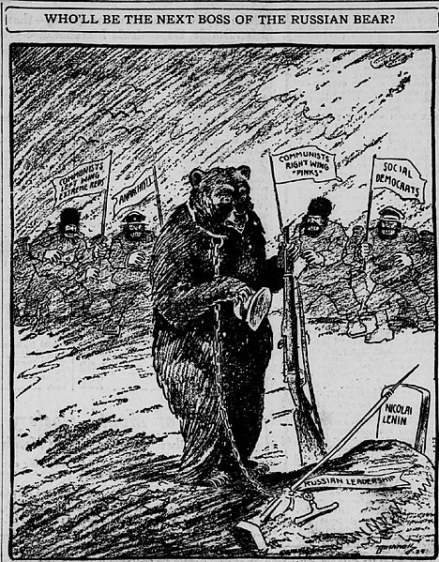
Grave reads: Nicolai Lenin

Sash reads: Russian leadership
The four flags read: Communists left wing extreme reds

Anarchists

Communists right wing “pinks”

Social democrats

See next page
Source 3
(A Soviet government poster produced in 1930 depicting the faces of Lenin and Stalin. The caption reads ‘Under the banner of Lenin for socialist construction’.)

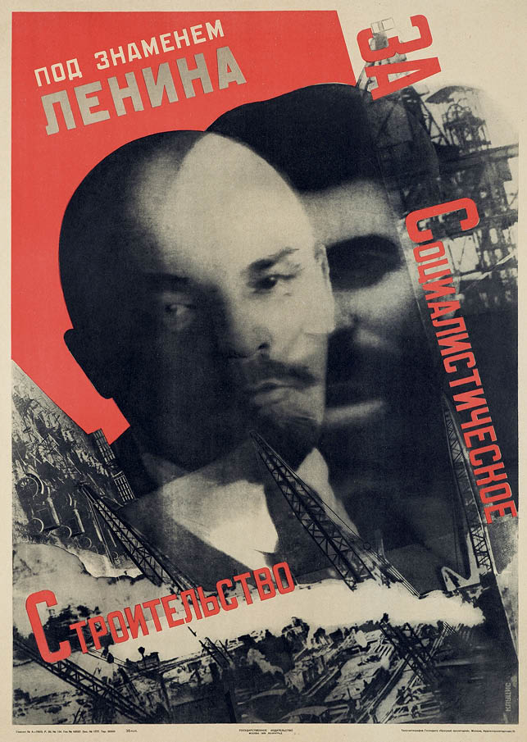

Source 4
(An extract from an article published in an academic journal in the U.S. in 1931 entitled: ‘Stalin’s Rise to Power’.)
Today Stalin stands, unchallenged, the supreme dictator of Soviet Russia. He has proved himself the master strategist among Soviet politicians. His rise from comparative obscurity to the highest pinnacle of power is no small achievement when it is remembered that he had to contend always with men who were undoubtedly his intellectual superiors… When Stalin began his climb to power the most brilliant leaders were still in the Kremlin- Trotsky, Rakovsky, Zinoviev, Kamenev of the Left Wing, and Rkyov, Bukharin, Tomsky of the Right Wing.
Any one of these men was superior to Stalin intellectually as well as in revolutionary experience. Had the Right and Left Wing leaders united, Stalin could hardly have been able to beat them. But they lacked political sagacity*. While Left and Right argued the question of revolutionary principle, Stalin quietly built up his party machine, and when it was perfected, skilfully pitted the Right Wing against the Left and blazed his own path to victory.
*Sagacity= the ability to make good judgements

END OF DOCUMENT SET
Set 3: Elective 3: China 1935 – 1989
Source 1
(Extracts from U.S. Secretary of State Dean Acheson’s statement on the outcome of the Chinese Revolution, in August 1949.)

The reasons for the failures of the Chinese National Government… do not stem from any inadequacy of American aid. Our military observers on the spot have reported that the Nationalist armies did not lose a single battle during the crucial year of 1948 through lack of arms or ammunition. The fact was that the decay which our observers had detected in Chungking early in the war had fatally sapped the powers of resistance of the Guomindang. Its leaders had proved incapable of meeting the crisis confronting them, its troops had lost the will to fight and its Government had lost popular support.
The Communists, on the other hand, through a ruthless discipline and fanatical zeal, attempted to sell themselves as guardians and liberators of the people. The Nationalist armies did not have to be defeated; they disintegrated. History has proved again and again that a regime without faith in itself and an army without morale cannot survive the test of battle.
The unfortunate but inescapable fact is that the ominous result of the civil war in China was beyond the control of the government of the United States. Nothing that this country did or could have done within the reasonable limits of its capabilities could have changed that result; nothing that was left undone by this country has contributed to it. It was the product of internal Chinese forces, forces which this country tried to influence but could not. A decision was arrived at within China, if only a decision by default.

Source 2
(A Chinese painting produced in 1953 entitled ‘The Founding of The Nation’ depicting the 1949 Proclamation of the PRC.)
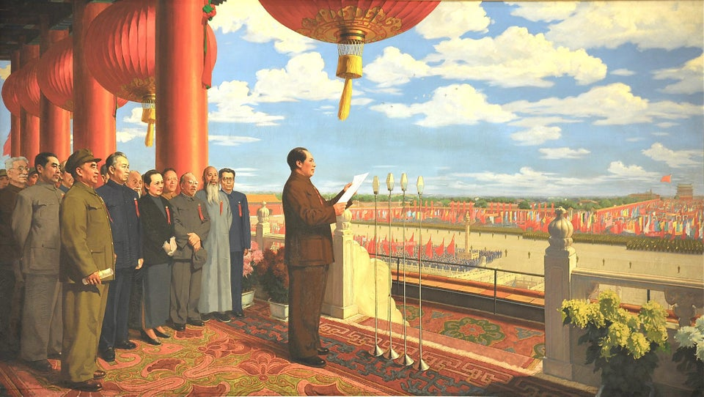

See next page
Source 3
(A Chinese government poster produced in 1971. The text of the poster reads: ‘Turn philosophy into a sharp weapon in the hands of the people’.)

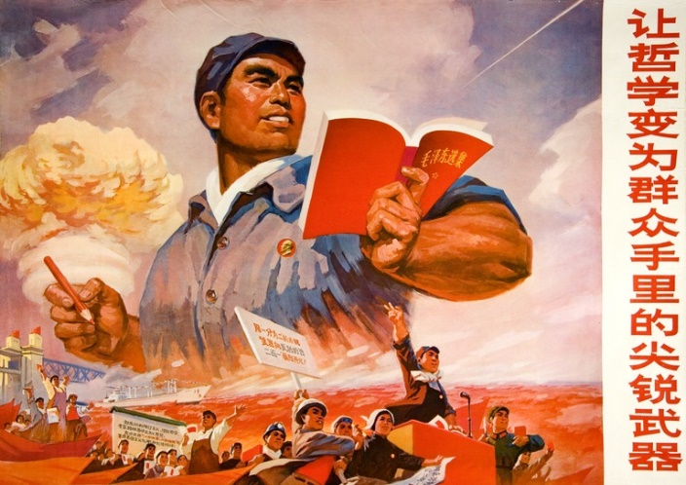

Source 4
(Extract from a report by Lin Bao presented to the 9th CCP Congress in April, 1969. The report addressed the progress of the Cultural Revolution and how to deal with suspected counter-revolutionaries.)
In the struggle against the enemy, we must carry out the policy ‘make use of contradictions, win over the many, oppose the few and crush our enemies one by one’ which Chairman Mao has always advocated. ‘Stress should be laid on the weight of evidence and on investigation and study, and it is strictly forbidden to obtain confessions by compulsion and to give them credence’.
We must implement Chairman Mao’s policies of ‘leniency towards those who confess their crimes and severe punishment of those who refuse to do so’ and of ‘giving a way out’. We rely mainly on the broad masses of the people in exercising dictatorship over the enemy.
As for bad people or suspects ferreted out through investigation in the movement for purifying the class ranks, the policy of ‘killing none and not arresting most’ should be applied to all except the active counter-revolutionaries against whom there is conclusive evidence of crimes such as murder, arson or poisoning, and who should be dealt with in accordance with the law.
As for the bourgeois reactionary academic authorities, we should either criticise them and see, or criticise them and give them work to do, or criticise them and provide them with a proper livelihood. In short, we should criticise their ideology and at the same time give them a way out.
END OF DOCUMENT SET
Set 4: Elective 1: Australia 1918-1955
Source 1
(A cartoon entitled ‘Taken Over’ that appeared in The Bulletin on 8 October 1941. The figures on the left are Independents Coles and Wilson, who helped get Curtin elected. All three are displaying the ‘V for victory’ symbol made popular by Winston Churchill.)

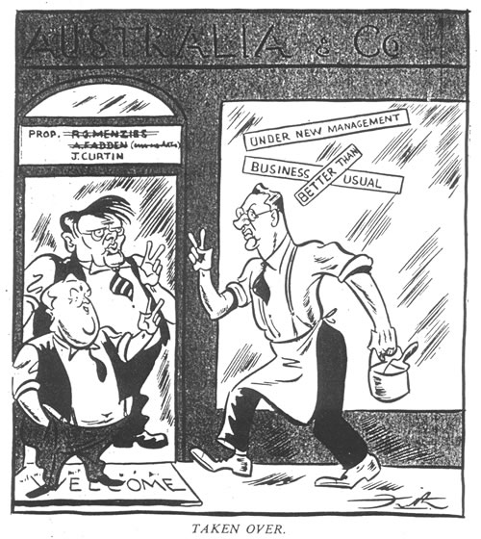

Source 2
(Extract from a newspaper article that appeared in The Age on 8 October 1941.)
The Prime Minister (Mr. Curtin), in an impassioned appeal at the launching of the £100,000,000 War and Conversion Loan in the Sydney town hall tonight, said the people of Australia wanted his Government to get to work at once for Australia. His first duty as Prime Minister was to discharge the obligations imposed upon him as the Leader of the Australian Government to wage the war to the maximum of Australia’s capacity…Mr. Curtin was frequently interrupted by prolonged bursts of applause, and when he rose to make his appeal the reception was tumultuous. Each Australian man and woman, he affirmed, had a decision to make regarding the future of the country, and the part to be played in what was hoped would be a civilised world.
There was no possibility of any country in the world escaping participation on one side or the other of the gulf that divided the aggressors from those attacked. Their only real security was to be strong in their power, and to enlist to their support those who, like themselves, would be strong. Mr. Curtin repeated that the Australian people were determined to wage the war to a successful conclusion. The £100,000,000 was required to discharge and meet commitments which the civilian population had already incurred towards the fighting services. The claims of these men and their families were paramount.
“It is total war for total domination by Germany and Italy,” Mr. Curtin declared, “and the only conceivable way in which we can meet so ruthless a nation as Germany, so totalitarian in its ideals, is by giving what we possibly can.”
See next page
Source 3
(A cartoon depicting Robert Menzies, entitled ‘My Hero’, that appeared in The Herald on 17 February 1953. Labor had recently won two state elections.)

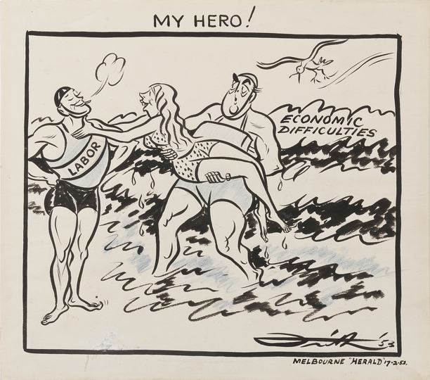

Source 4
(Extract from National Archives of Australia webpage titled ‘Robert Menzies: during office’.)
Although Menzies’ dominance of Australian politics in the 1950s and early 1960s benefited from the misfortunes that befell the Labor Party and his good luck in coming to power as the economy began to pick up, Menzies also had considerable skill as a politician. He was one of the first federal party leaders who actively targeted women’s votes. Identifying women as usually more conservative in their voting habits than men, Menzies was always careful to emphasise how issues like industrial relations and defence were of concern to women.
Menzies’ deployment of the ‘Communist bogey’ was masterful. He genuinely believed that Communism posed a real threat to Australian society, both at home and abroad. He raised the threat of Communism before each election, provoked Opposition disarray and scared the more impressionable voters back to supporting the coalition. Menzies was helped in this tactic by the fact that many recent immigrants were refugees from Eastern Europe who harboured deep fears of Communism.
The early poll was another tactic that Menzies used to great advantage. Three of the seven federal elections he called during his second period as Prime Minister were held at least 12 months ahead of time.

END OF DOCUMENT SET
Set 5: Elective 2: Russia and the Soviet Union 1914 - 1945
Source 1
(Photograph of Lenin in Red Square giving a speech to military training troops, May 1919.)
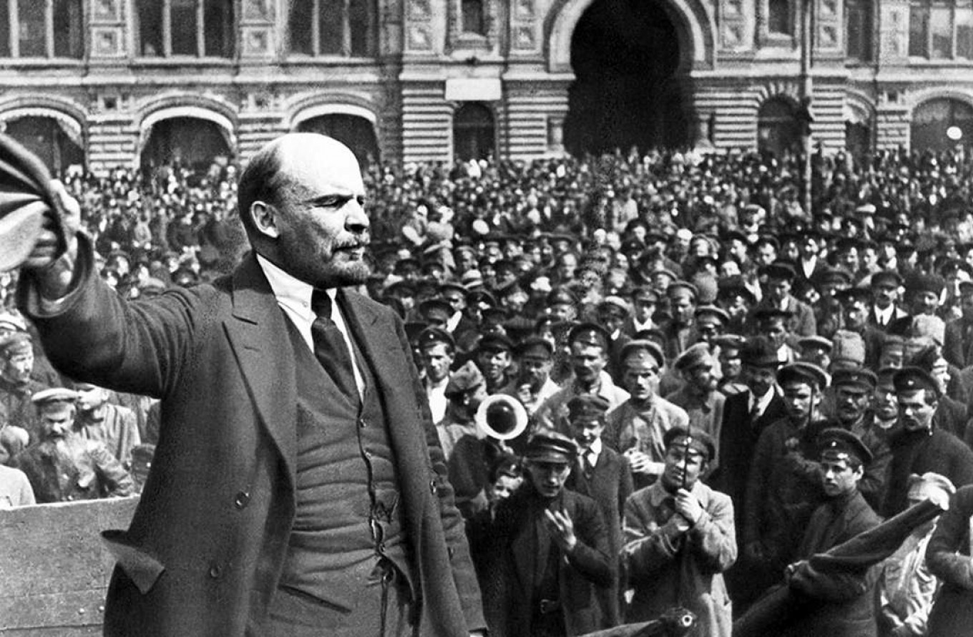

Source 2
(Extract describing the leadership of Lenin from ‘Stalin and Socialism’ by Marxist historian C. L. R. James. Published in 1937.)

The range and honesty of his (Lenin’s) intellect, his power of will, the singular selflessness and devotion of his personal character, added to a great knowledge and understanding of men, enabled him to use all types of intellect and character in a way that helped to lift the Bolshevik party between 1917 and 1923 to the full height of the stupendous role it was called upon to fulfill.

No body of men ever did so much, and how small most of them really were we can realise only by looking at what they became the moment their master left them. Lenin made them what they were. He was sly and manoeuvred as all who have to manage men must manoeuvre. But through all the disagreements of those years which often reached breaking-point he never calumniated*, exiled, imprisoned or murdered any leaders of his party. He was bitter in denunciation, often unfair, but never personally malicious.

He was merciless to political enemies, but he called them enemies, and proclaimed aloud that if they opposed the Soviet regime he would shoot them and keep on shooting them. But Trotsky tells us how careful he was of the health of his colleagues; hard as he was it is easy to feel in his speeches, on occasions when the party was being torn by disputes, a man of strong emotions and sensitiveness to human personality. In his private life he set an unassuming example of personal incorruptibility and austere living. No man could ever fill his place, but it was not impossible that someone able and willing to act in his tradition could have carried on where he left off, and all knew that Trotsky was best fitted for that difficult post.

*calumniate= make false and defamatory statements about.

See next page
Source 3
(A Soviet government poster produced in 1944. The text of the poster reads: ‘Let's go forward, destroy German invaders and throw them out from our Motherland!’.)
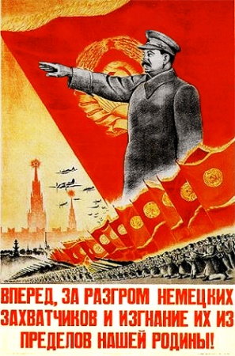
Source 4
(Extract from an article by Robert Conquest that appeared on The Guardian newspaper website in 2003, entitled ‘Stalin's reputation as a ruthless master of deception remains intact’.)
Historians have written that Stalin was a "consummate actor". When post-Soviet Russian historians saw that Stalin had deceived Roosevelt in crucial World War Two negotiations, academics pointed out that this was perhaps not very surprising, since he had even managed to deceive Alexei Rykov, Lenin's successor as head of the Soviet government, who had served with him on the politburo in daily, close contact for over a decade - only to be shot later.
In fact, if we look back at Stalin, we see not only terror and ruthlessness, but - even more - deception. Not only in such things as the faked public trials, the disappearance of leading figures, of writers, of physicists, even of astronomers, but in the invention of a factually non-existent society. The British socialists Sydney and Beatrice Webb were taken in by the not very sophisticated trick of having meaningless elections, trade unions, economic claims and so on.
One major attribute of Stalinism was stupefaction or stultification*. His subjects, or dupes, had to act as if they believed what the Kremlin was telling them in the press, on the radio. Anna Akhmatova, the poet, said that no one could understand the Soviet system who had not been subjected to the continuous roar of the Soviet radios at street corners and elsewhere. And, with all that, the effective banning of non-Stalinist thought, or its expression.
*stupefaction or stultification= unable to think clearly, dulled, useless
END OF DOCUMENT SET
Set 6: Elective 3: China 1935 – 1989
Source 1
(Chinse government poster produced in 1954. The text of the poster reads: ‘Turn China into a prosperous, rich and powerful industrialised socialist country under the leadership of the Communist Party and Chairman Mao!’)
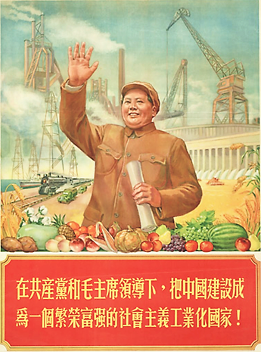

Source 2
(Extract from ‘Mao Zedong’ by Zhou Enlai. Published in China, 1978.)
During the Great Revolution, Chairman Mao was already aware that the peasants were the largest ally and that the people's revolution could not triumph without them. And sure enough, the revolution suffered defeat because his views weren't listened to. Later, when we got to the countryside, Chairman Mao saw that in order to carry out the revolution it is necessary not only to rely on the peasants, but also to win over the middle and petty bourgeoisie. As Chiang Kai-shek's counter-revolutionary treachery became further exposed, only the comprador-bureaucrat and feudal landlord classes supported him. But a group of people inside the Communist Party made "Left" deviationist mistakes and were very narrow in their outlook, holding that the middle and petty bourgeoisie were unreliable. They didn't listen to Chairman Mao, and the result was that the revolution suffered another setback and we had to march 25,000 li (12,500 kilometres).
Then Chairman Mao proposed that we unite with Chiang Kai-shek and other members of the upper strata to resist Japanese aggression. But some people said that if we wanted unity, there shouldn't be any struggle. Chairman Mao replied that Chiang and the others were our domestic enemy; we were uniting with them in order to fight the national enemy. But they were not reliable partners or allies, and we must guard against them; otherwise, they might turn on us. We took measures to avert Right deviations and to prevent unqualified compromises.

See next page
Source 3
(Cartoon by Swiss cartoonist Patrick Chappatte depicting Deng Xiaoping, published 17 June 1989.)

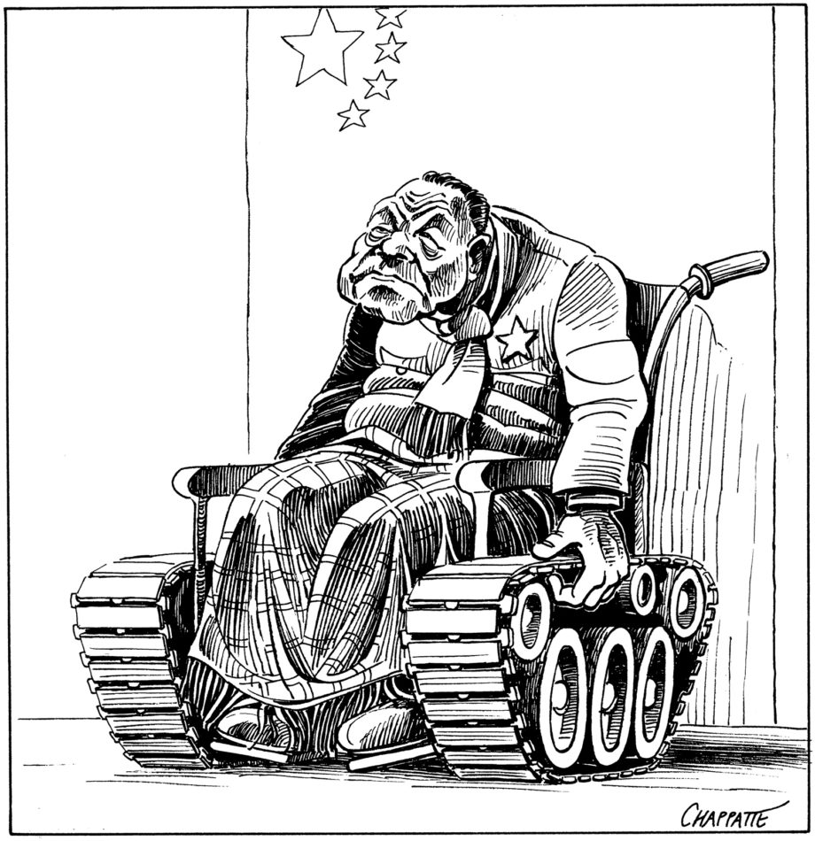

Source 4
(Extract from Journal Article titled ‘Deng Xiaoping: The Politician’, published in Britain, 1993.)

Any politician with a career as long and diverse as Deng Xiaoping defies simple designation. Deng Xiaoping the politician has been a complex figure. He has embodied contradictory tendencies and beliefs.

While Deng was a comprehensive reformer, there were limits to each of his reforms. His intolerance of liberalism and direct challenges to Communist Party political hegemony always co-existed with his desire to loosen the Party’s control over the economy. It was Deng… who personally initiated the process of political reform during the 1980s, only to recoil and tighten the Party’s grip on the instruments of coercive power in the 1990s. He would not balk at the necessity of using force or coercion in certain instances, yet did much to curtail the arbitrary repression of the Maoist era and enliven the social and professional lives of Chinese from many walks of life. Dramatically improving the standard of living and diversity of life for one-fifth of the world’s population, while denying them fundamental political and human rights, will no doubt be Deng’s most enduring legacy.

In policy-making Deng was pragmatic and made the deals necessary to achieve his domestic goals, yet was often uncompromising in statecraft when he perceived matters of principle and national interest to be at stake. He was consistent in advocating economic reform that adopted market methods, yet he still sought protection of the state sector… Deng believed in socialism and Communist Party supremacy, although he did much to undermine both.

END OF DOCUMENT SET
ACKNOWLEDGEMENTS

Set 1: Elective 1: Australia 1918–1955

Source 1 Cartoon by Ted Scorfield published in The Bulletin, 3 November 1954.
Retrieved from https://nla.gov.au/nla.obj-528071090/view?partId=nla.obj-528137042#page/n4/mode/1up

Source 2 An extract from an a speech by Evatt during Parliamentary Debates 19 October 1955. Retrieved from https://nla.gov.au/nla.obj-52794728/view?partId=nla.obj-94367101#page/n0/mode/1up
Source 3 Cartoon by John Frith published in The Herald, March 1955. Retrieved from https://frith.moadoph.gov.au/the-best-of/6-party-unity/

Source 4 Extract from an article called ‘The Split’ from website called ‘The Petrov Affair’. Retrieved from https://petrov.moadoph.gov.au/the-split.html

Set 2: Elective 2: Russia and the Soviet Union 1914–1945

Source 1 Extract from Lenin’s Last Will and Testament. Originally published in ‘Lenin, Collected Works, vol.36’, published in 1966. Retrieved from http://www.historyguide.org/europe/testament.html

Source 2 Cartoon published in The Glendale Evening News, 28 January, 1924. Retrieved from https://upload.wikimedia.org/wikipedia/commons/7/70/The_Glendale_Evening_News_1924-01-28_%28IA_cgl_005216%29.pdf

Source 3 A poster produced by Gustav Klutsis in 1930. The text reads ‘Under the Lenin banner for socialist construction’. Retrieved from https://press-files.anu.edu.au/downloads/press/n2129/html/ch02.xhtml?referer=&page=8#

Source 4 Extract from ‘Stalin’s Rise to Power’ by Leo M. Glassman. Published in ‘Current History’ (1916-1940) Vol. 34, No. 1 (April 1931). Retrieved from http://www.jstor.org/stable/45336496

Set 3: Elective 3: China 1935 – 1989
Source 1 Extract from report by U.S. Secretary of State, Dean Acheson on the outcome of the Chinese Revolution, August 1949. Retrieved from https://alphahistory.com/chineserevolution/dean-acheson-chinese-revolution-1949/

Source 2 Painting by Dong Xiwen titled ‘The Founding of the Nation, 1953.
Retrieved from https://www.reddit.com/r/PropagandaPosters/comments/q7xbha/the_founding_of_the_nation_oil_on_canvas_by_dong/

Source 3 Chinese government poster produced in 1971. The text reads ‘Let philosophy become a sharp weapon in the hands of the people’.
Retrieved from https://library.ucsd.edu/dc/object/bb92162750

Source 4 Extract from report by Lin Biao to the 9th CCP Congress, April 1969.
Retrieved from https://alphahistory.com/chineserevolution/lin-biao-restraint-cultural-revolution-1969/

Set 4: Elective 1: Australia 1918–1955
Source 1 Cartoon by John Frith published in The Bulletin, 8 October 1941.
Retrieved from https://john.curtin.edu.au/aspirations/activities/1cartoonpm.html

Source 2 Extract from newspaper article published in The Age, 8 October 1941.
Retrieved from https://www.theage.com.au/national/from-the-archives-1941-curtin-becomes-pm-of-a-nation-at-war-20210913-p58rcf.html

Source 3 Cartoon by John Frith published in The Herald, 17 February 1953.
Retrived from https://frith.moadoph.gov.au/the-cartoons/2-the-nation-was-experiencing-ec/

Source 4 Extract from an article on Robert Menzies’ time in office from the National Archives of Australia website. Retrieved from https://www.naa.gov.au/explore-collection/australias-prime-ministers/robert-menzies/during-office

Set 5: Elective 2: Russia and the Soviet Union 1914–1945
Source 1 Photograph of Lenin in Red Square, May 1919.
Retreived from https://www.themoscowtimes.com/2019/04/16/on-this-day-vladimir-lenin-arrives-in-st-petersburg-triggering-the-october-revolution-a65247

Source 2 Extract from ‘Stalin and Socialism’ by C. L. R. James, published in 1937.
Retreived from https://spartacus-educational.com/RUSlenin.htm

Source 3 Russian government poster produced in 1944. The text reads: ‘Let’s go forward, destroy German invaders and throw them out from our Motherland!’. Retrieved from https://www.allworldwars.com/Russian%20WWII%20Propaganda%20Posters.html

Source 4 Excerpt from online article by Robert Conquest, 5 March 2003 entitled ‘Stalin’s reputation as a ruthless master of deception remains intact.’
Retrieved from https://chineseposters.net/posters/e13-866

Set 6: Elective 3: China 1935 – 1989
Source 1 Chinese government poster produced in 1954. The text reads: ‘Turn China into a prosperous, rich and powerful industrialised socialist country under the leadership of the Communist Party and Chairman Mao!’. Retrieved from https://retrographik.com/eliminate-the-four-old-1967-mao-propaganda-poster/

Source 2 An extract from ‘Mao Zedong’ by Zhou Enlai, published in 1978. Retrieved from https://spartacus-educational.com/COLDmao.htm

Source 3 A western cartoon by Patrick Chappatte published 17 June 1989. Retrieved from https://www.chappatte.com/en/images/deng-xiaoping-after-tiananmen-cartoon-published-june-17-1989/

Source 4 Extract from journal article ‘Deng Xiaoping: The Politician’ by David Shambaugh. Published in ‘The China Quarterly’ no. 135, 1993. Retrieved from http://www.jstor.org/stable/654098

END OF SOURCE BOOKLET

